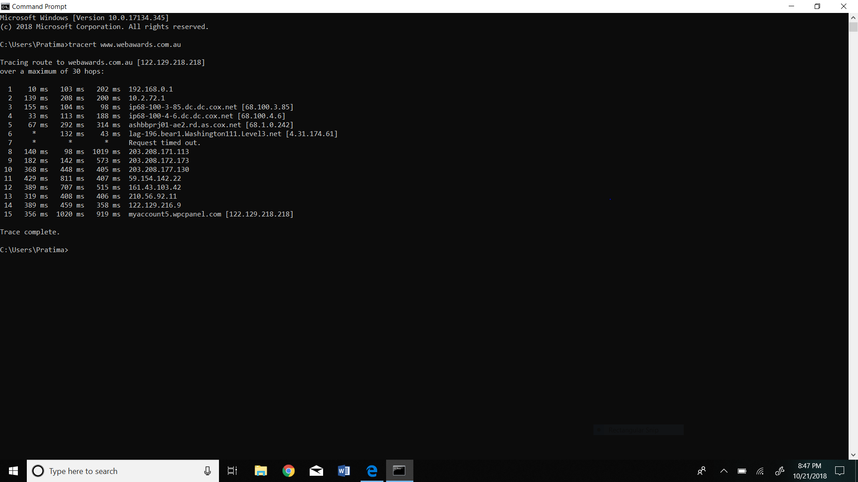

1.What is your computer IP address?(This is not included in your traceroute results).

The IP address of my computer is 192.168.0.29.

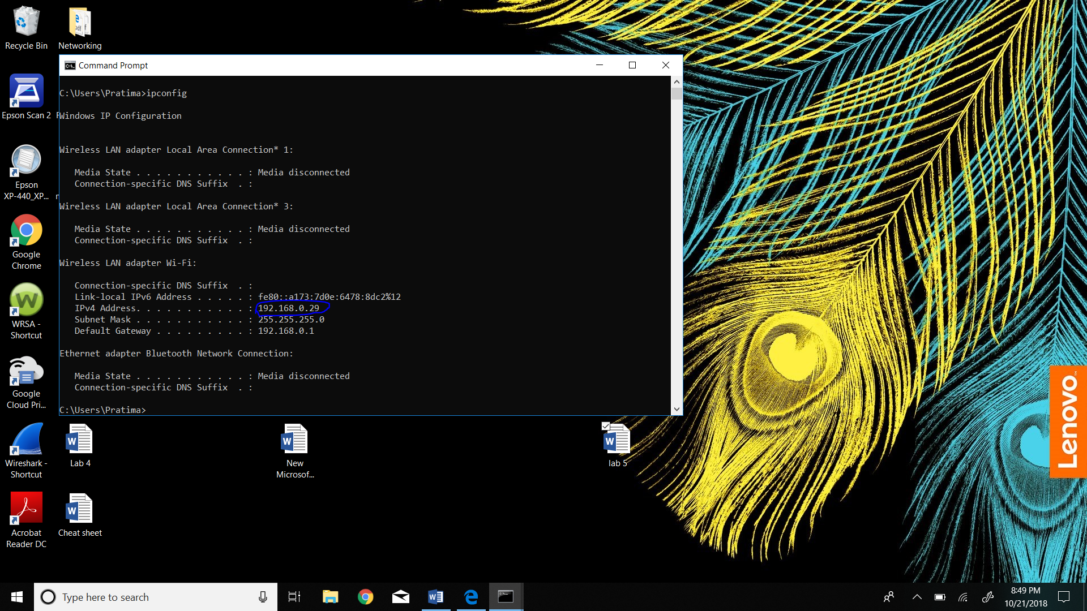

2.With reference to private/public IP address.What type of IP address is the first IP from your traceroute result.

The first IP from my traceroute result is 192.168.0.1 and that is private Ip address.

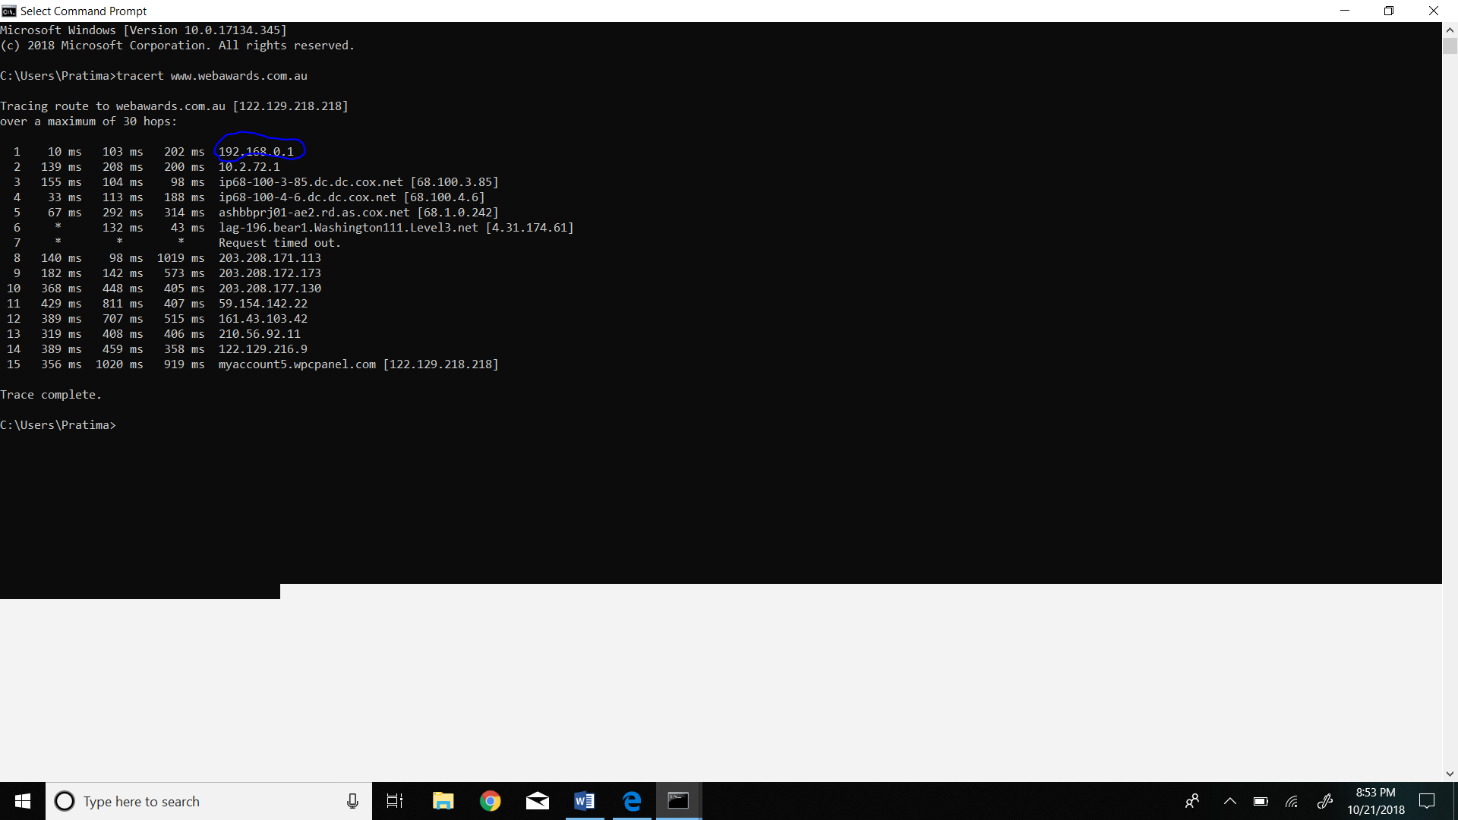

3. With reference to private/public IP address.What type of IP address is the second IP from your traceroute result.

The second type of IP address in my computer is 10.2.72.1 and that is private IP address.

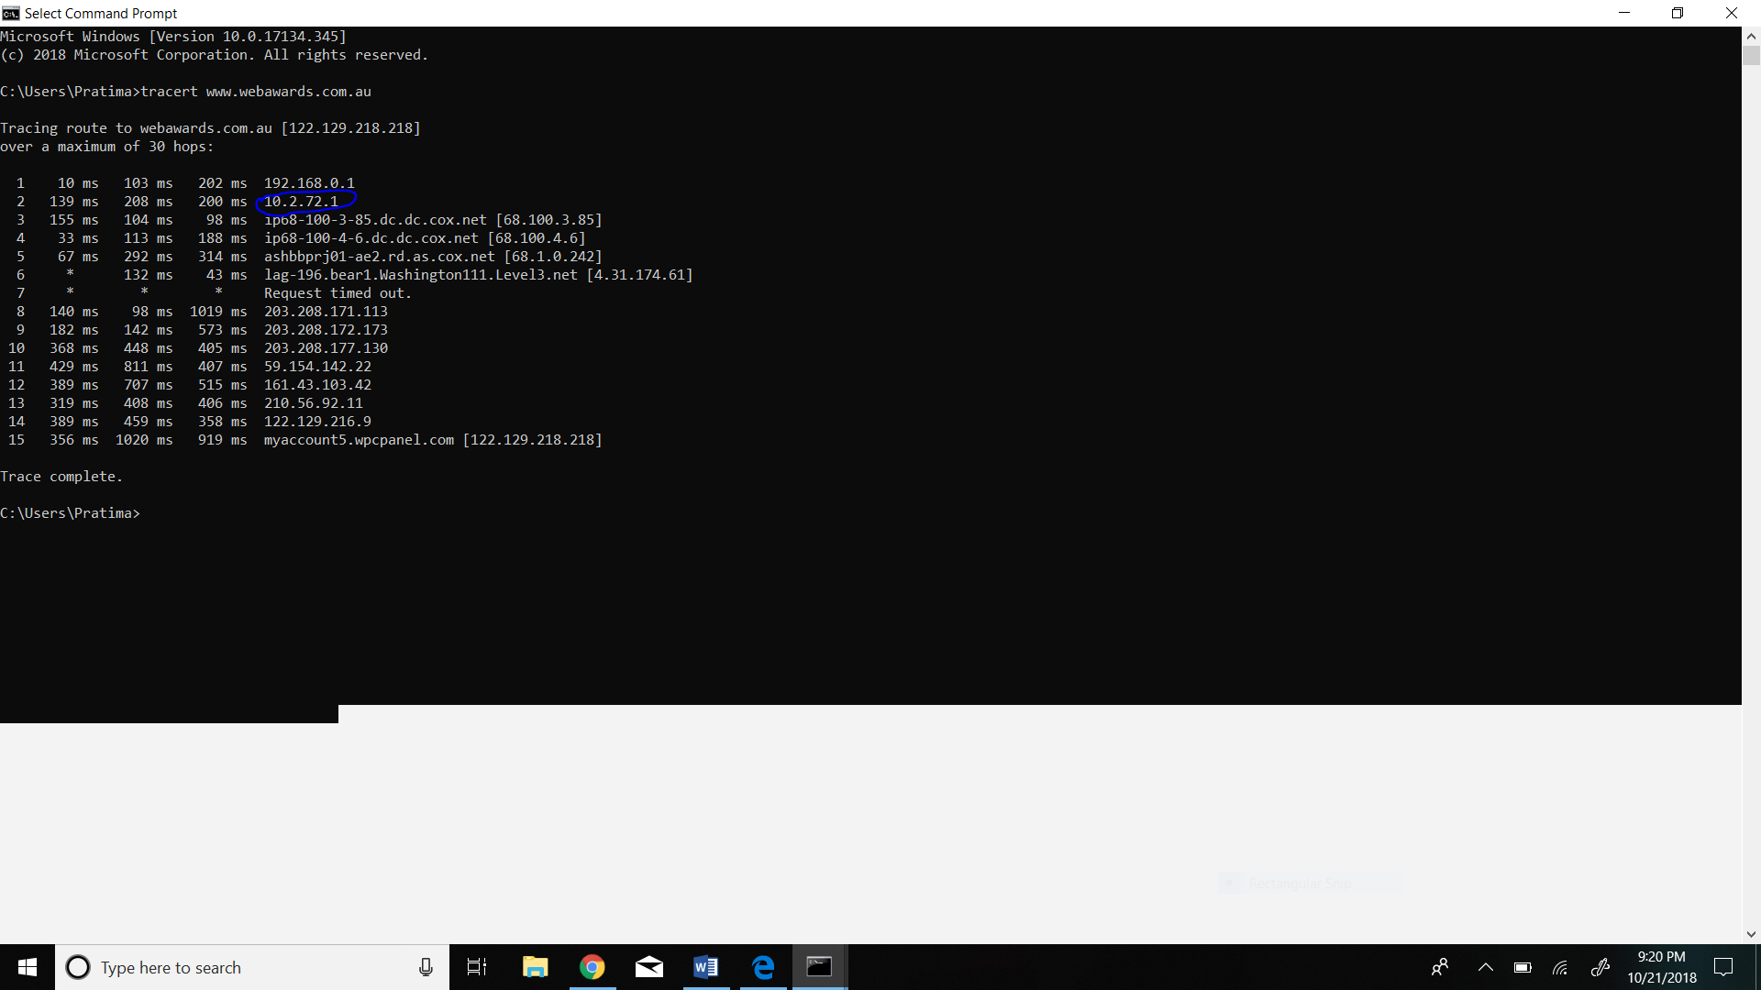

4. In a tabular format (use table example below), and in sequential order. Indicate the location of each IP address (include state for US states) and the organization that owns the IP address. (Use https://www.ultratools.com/tools/ipWhoisLookup to look up IP address whois information).

|  |  |  |  |
| --- | --- | --- | --- |
| Hop Count | IP address | Organization (IP Owner) | Location (US state)/Country |
| 1 | 192.168.0.1 | IANA | CA,USA |
| 2 | 10.2.72.1 | IANA | CA,USA |
| 3 | 68.100.3.85 | COX Communication Inc | GA, USA |
| 4 | 68.100.4.6 | COX Communication Inc | GA,USA |
| 5 | 68.1.0.242 | COX Communication Inc | GA,USA |
| 6 | 4.31.174.61 | LULT-STATIC | CO,USA |
| 7 | 203.208.171.113 | SINGTEL-IX_AP | Singapore |
| 8 | 203.208.172.173 | SINGTEL-IX_AP | Singapore |
| 9 | 203.208.177.130 | SINGTEL-IX_AP | Singapore |
| 10 | 59.154.142.22 | OPTUSCOM-AU | AU |
| 11 | 161.43.103.42 | OPTUSCOM-AU | AU |
| 12 | 210.56.92.11 | ESCAPENET | AU |
| 13 | 122.129.216.9 | WEB-PROPHETS | AU |
| 14 | 122.129.218.218 | WEB-PROPHETS | AU |

5. In your own words, explain everything you just did, and what route did your packet took from source to destination. How many US states did your packet go through? How many countries if any?

When I use traceroute diagonistic tool to packet route across the network, the packet went through 30 hops with different IP address each time.In this case, my packet went through Los Angeles as a source to Gorgia, Colorado, Singapore and finally it reached to its destination to Australia.So here the packet went through three(California,Gorgia and Colorado) different state and three(USA, Singapore and Australia) country.